Interior design is the art and science of enhancing the interior of a space so that the user can enjoy a healthy, functional and aesthetically pleasing environment. Apart from selecting colours and arranging furniture, it encompasses a diverse array of elements, including spatial planning, lighting, furniture design, and decorative arts.

The goal of interior design is not only to create visually appealing spaces, but to also optimise functionality, improve the quality of life, and reflect the unique personality or brand identity of the inhabitants or users.

## Contextual Influences on Interior Design

The evolution of interior design has been shaped by various contextual influences including **cultural**, **social**, **economic**, and **technological**. Throughout history, different civilizations have left their mark on interior design, with each era reflecting the prevailing architectural styles, artistic movements, and societal values of the time.

For example, ancient civilizations such as the **Egyptians** and the **Mesopotamians** applied interior design to create grandiose palaces and temples, adorned with intricate murals, ornate furniture, and lavish textiles (Fig. 2) that were often filled with religious symbolism. In contrast, the classical period of **ancient Greece** and **Rome** favoured symmetry, proportion, and harmony.

These can be identified in the columned structures and elegant frescoes that characterised these spaces.

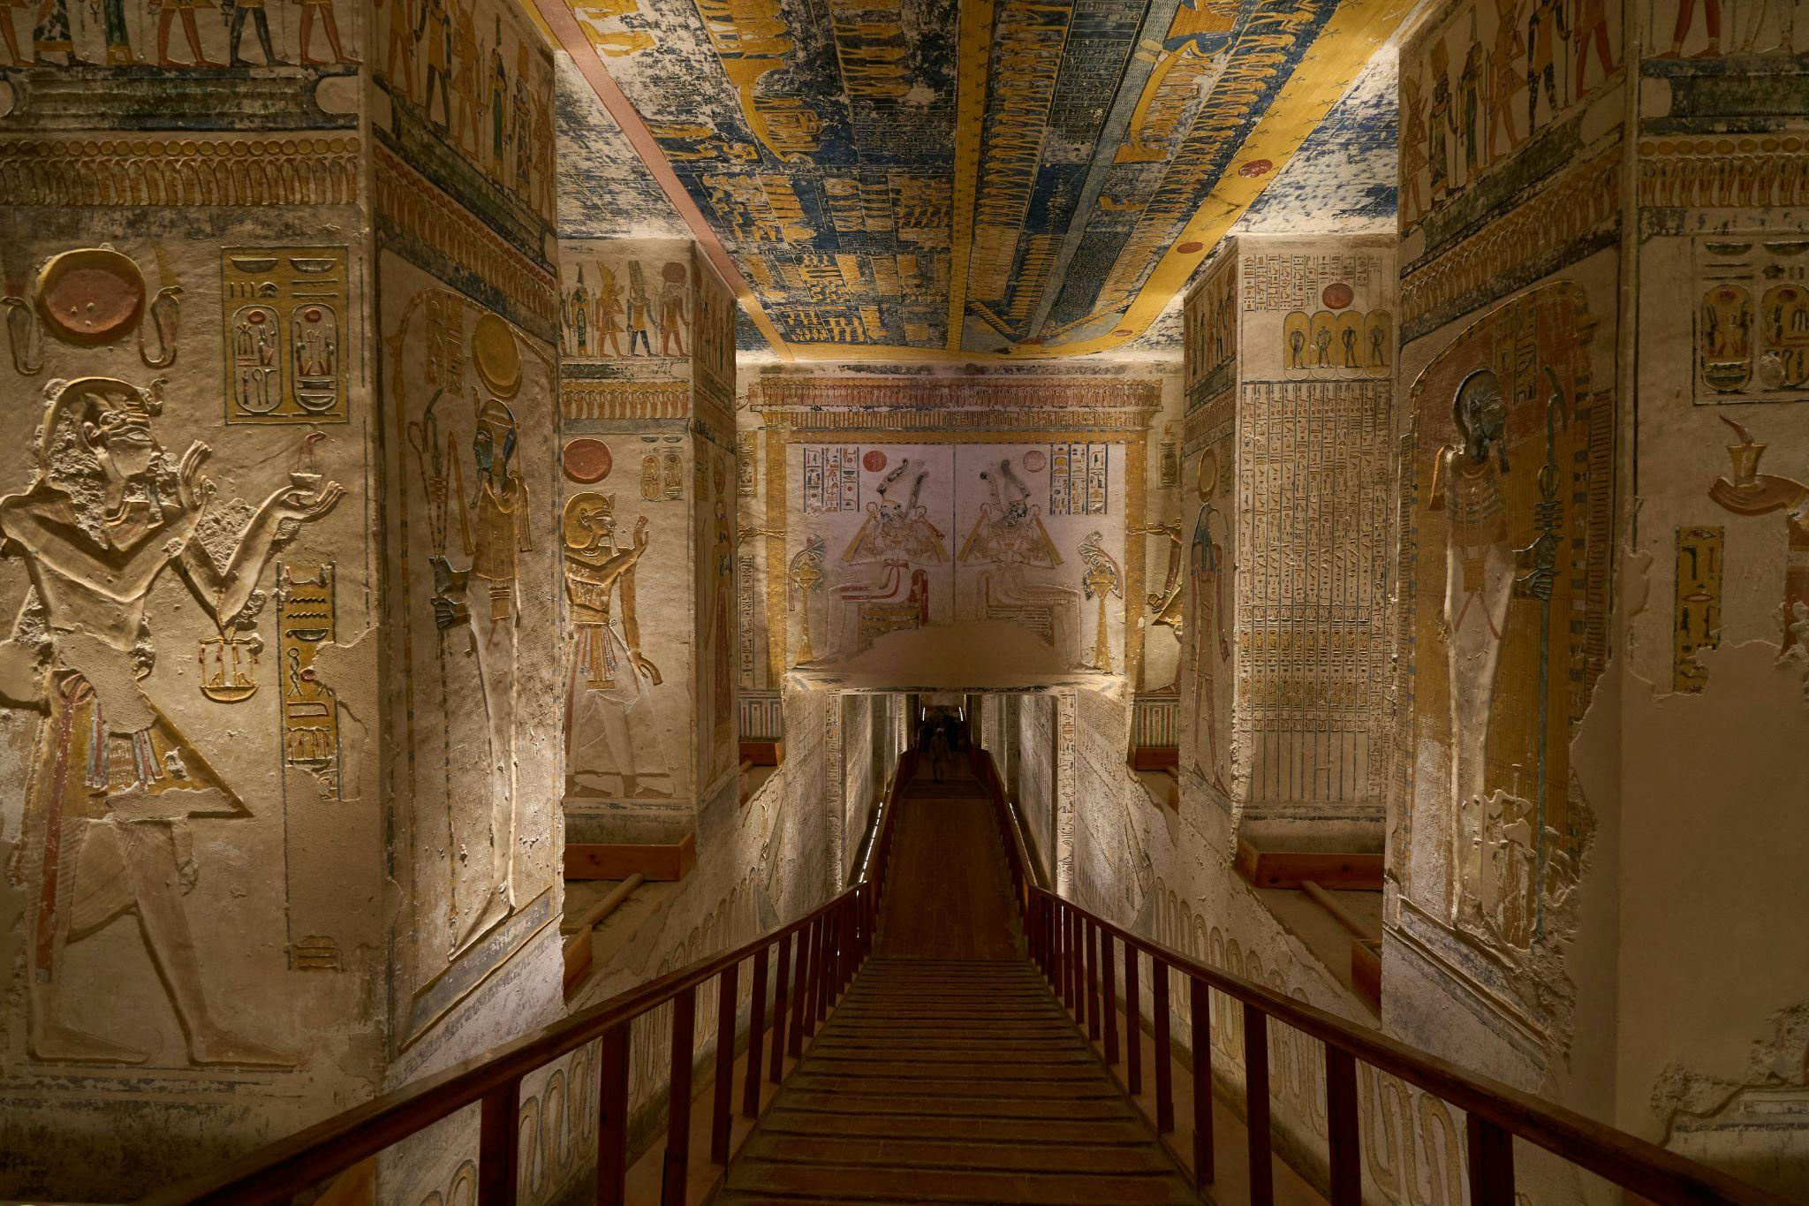

Fig 1. Unsplash (2021), Egyptian Interior

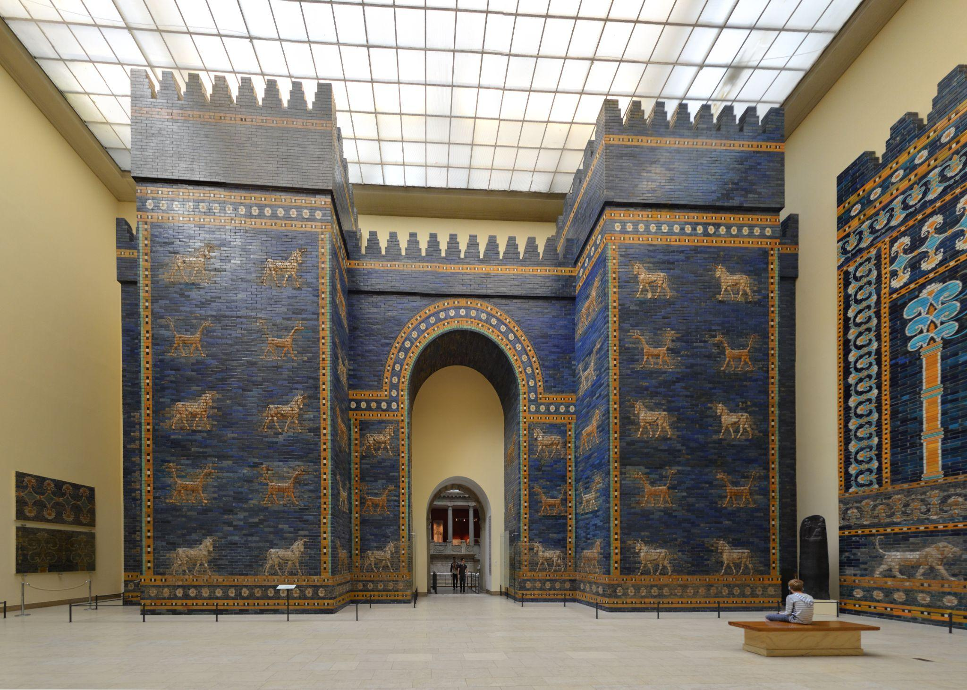

Fig 2. Wikimedia Commons (n.d.), The Ishtar Gate, Mesopotamia: Ancient Art and Architecture

Fast forward to the Renaissance period and an immense transformation of interior design, with a renewed focus on humanism, perspective, and realism. This era saw the emergence of renowned architects and designers, like Leonardo da Vinci and Michelangelo, who incorporated elements of classical antiquity into their designs while also pioneering new techniques in perspective drawing and spatial organisation.

The **industrial revolution** of the 18th and 19th centuries introduced the concepts of **mass production** and **urbanisation**, leading to significant changes in interior design. Furniture and decorative items became more accessible to the masses, as many were being produced in factories and through mechanical manufacturing processes. This enabled the rise of various design movements such as Art Nouveau, Arts and Crafts, and Art Deco. Each one of these movements was characterised by its distinctive aesthetic and philosophy.

In response to shifting cultural norms, technological advancements, and global events of the 20th century, interior design continued to evolve rapidly. The **Bauhaus** movement, founded in Germany in the early 20th century, emphasised the marriage of **form and function**, pioneering innovative design principles that would shape modernist architecture and interior design for decades to come. Finally, the post-war period witnessed the arrival of **mid-century modernism**, characteristics of which were clean lines, organic forms, and an emphasis on simplicity and functionality.

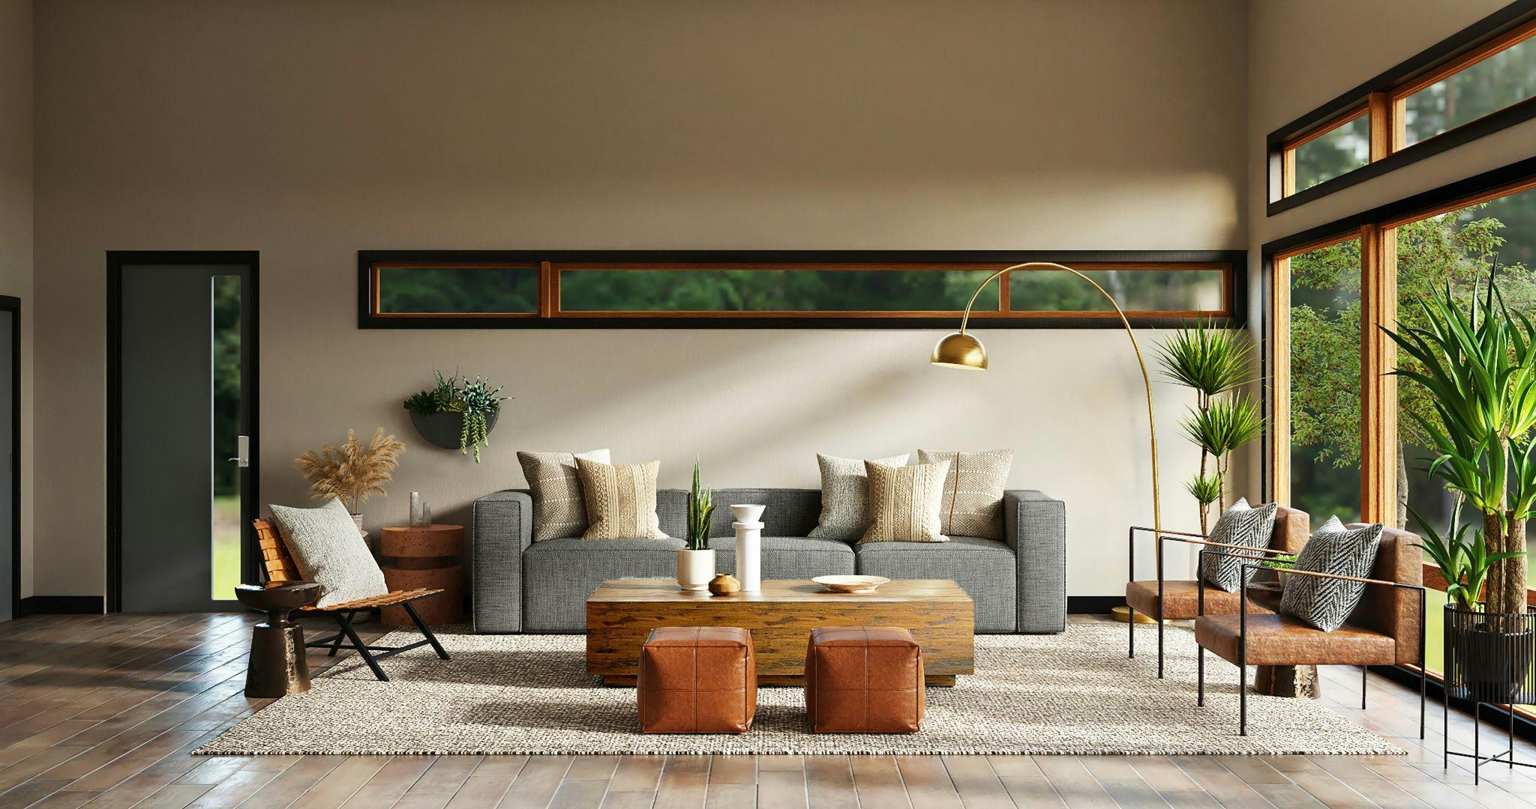

Fig 3. Unsplash (n.d), Mid-Century Modern Style Living Room

## The Evolution of Interior Design as a Profession

Until around the 20th century, Interior Design was still considered a mere decorative pursuit but with the arrival of Bauhaus, and the combination of various creative and artistic industries, it slowly began to develop into a recognized profession. It was through the need to define this combination of the arts, such as photography, architecture, painting, furniture etc., that interior design was born. Prior to this, interior decoration was primarily seen as a feminine pursuit, practised by wealthy homeowners and aristocrats.

With the rise of modernism and the increasing complexity of interior spaces, the demand for professional expertise grew. Influential figures such as Elsie de Wolfe, often regarded as the first interior decorator, and pioneering designers like Frank Lloyd Wright and Le Corbusier, helped put interior design on the map as a distinct discipline, deserving of professional recognition.

The establishment of design schools and professional organisations further solidified interior design as a profession, providing aspiring designers with the necessary education, training, and credentials to excel in the field. Today, interior designers work across a diverse range of sectors including residential, commercial, hospitality, healthcare, and retail, collaborating with architects, engineers, and other professionals to create spaces that are both functional and visually compelling.

# The Importance of Interior Design

In today's fast-paced world where people spend much of their time indoors, the importance of interior design cannot be underestimated. Beyond its aesthetic appeal, well-designed interiors have a profound impact on our physical, mental, and emotional well-being.

For example, research has shown that factors such as lighting, colour, and spatial layout can influence mood, productivity, and overall satisfaction. A thoughtfully designed workspace can boost employee morale and creativity, while a carefully curated store design can enhance the customer experience and increase sales.

Moreover, interior design plays a crucial role in addressing environmental concerns such as sustainability and resource efficiency. By incorporating sustainable materials, energy-efficient technologies, and biophilic design principles, designers can create spaces that minimise environmental impact while maximising the comfort and health of the user.

In conclusion, interior design is a multifaceted discipline that encompasses art, science, and human psychology. Whilst shaped by historical precedents and contemporary influences, it continues to evolve in response to changing societal needs and technological advancements. As we navigate an increasingly complex and interconnected world, the role of interior design in shaping our built environment and enriching our lives will only continue to grow in significance.

Fig 4. Pixabay (2024), A Luxurious Lounge